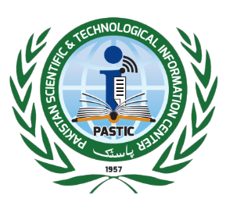
Pakistan Scientific & Technological Information Centre (PASTIC)
Pakistan Science Foundation (PSF)
Quaid-e-Azam University Campus, Islamabad
P.O. Box: 1217, Islamabad, Tel: +9251-9248103-4, Fax: +9251-9248113,
Email: dg@pastic.gov.pk, URL: www.pastic.gov.pk

INVITATION TO BID

Pakistan Scientific and Technological Information Centre (PASTIC), a National Agency for collection and dissemination of scientific information intends to invite sealed tenders from well-reputed Firms/General Order Suppliers having NTN & GST number dealing in supply of Printing Material (single stage one envelope) as described in tender document. A complete set of Tender document and detail specification of the items along with terms & condition for the procurement can be purchase on cash payment of Rs. 2,000/- (non-refundable) for each set from the office of undersigned, during working hours. It is further advised that receipt for Rs. 2,000/-may also be attached on top of the tender set, at the time of submission without receipt tender will not be accepted.

The Interested Firms/ Parties may submit their sealed bids against each items along with Earnest money of Rs. 100,000/- (for period of one year) in shape of pay order in favour of Additional Director (Admin), PASTIC on or before 01- 12-2022 till 11.00 a.m. which will be opened on the same day at 11:30 a.m. in the presence of the bidders (who wish to attend) in Committee room of PASTIC National Centre, Quaid-i-Azam University Campus, Islamabad. Firms are requested to quote their rates on unit price basis including GST which will be valid up to 31-12-2023, however quantity will be demanded by the procuring agency on need basis during the year 2023.

(GHAFFAR AHMED)
Additional Director (Admin)
Phone: 051-9248105
051-9248116

